**SLA: Service Level Agreement:**

* **SLA is a Process Rule. SLA is applied for the Tasks routed to complete within given interval.**
* **SLA Contains Intervals, Urgency & Escalation Options.**
* **SLA is called at Assignment Level( Process Flow) or Flow Level ( Screen flow)**

**Ex : Airtel:**

* **1 user : 24 hours ( Less Priority)**
* **100 users - 10 hrs ( High Priority)**
* **Every user: 1-2 hr (Critical )**

**SLA Contains Different Time Intervals:**

1. **Goal Time**
2. **Dead Line Time**
3. **Passed Dead Line Time**

**How to Intervals are calculated using GOAL, DEADLINE & PASSED DEADLINE**

* **GT: 1hr  -> Goal Time starts calculating the moment SLA is Started**
* **DLT: 2hr -> Dead Line Time starts calculating the moment SLA is Started/Created**
* **PDLT: 1hr -> The Moment Dead Line time is Completed, Passes Dead line time will start**
* **8 AM: Login ( Interval Calculation will be as shown Below)**
* **Goal Time:  9 AM**
* **Dead Line Time:  10 AM**
* **Passes Dead Line Time: 11 AM**

**GT & DLT : Starts Calculating at the same time. DLT interval should be greater than Goal Time interval.**

**PDLT: Starts calculating once Dead line Time is completed.**

**Urgency/Priority:**

**Urgency is priority of the task**

**we can assign urgency values in every interval**

**Urgency Max Value - 100**

**Urgency calculation = Initial Urgency + Interval Urgency(GT, DLT, PDLT)**

**How to Calculate Urgency:**

**Initial Urgency: 5**

**Goal Time Urgency: 20  ( 25)   ( Initial + GT)**

**Dead Line Urgency: 20   ( 45)  ( Initial + GT + DLT)**

**Passed Dead Line Time Urgency: 20  ( 65)  ( Initial + GT + DLT + PDLT)**

**Ex: Calculate Urgency at each Interval:**

**Goal Time:   5 + 30 = 35**

**Dead Line Time:  35+ 50 = 85**

**Passed Dead Line Time : 85 + 60 = 100 ( Urgency Max Value will stop @ 100)**

**Escalation Parameters:( Actions)**

**Apply Data Transform:**

**Call Flow:**

**Advanced Flow: call particular step in flow**

**Transfer:**

**Run Activity:**

**Notify Party:**

**Notify Assignee:**

**Notify Manager:**

**Working with SLA Rule:**

**SLA is a Process Rule:**

**Create an SLA & apply on Manager approval Assignment.**

**- Auto Transfer this Assignment to any User Portal when the Goal Time is completed( Goal  Time : 2min)**

**Access GroupNames for Different Portal Id's:**

**Developer Portal: Division Name: Administrators**

**Manager Portal: Division Name: Managers**

**User Portal: Division Name: Users**

**Create User Portal ID:**

**Open Developer ID & Use Save as Option:**

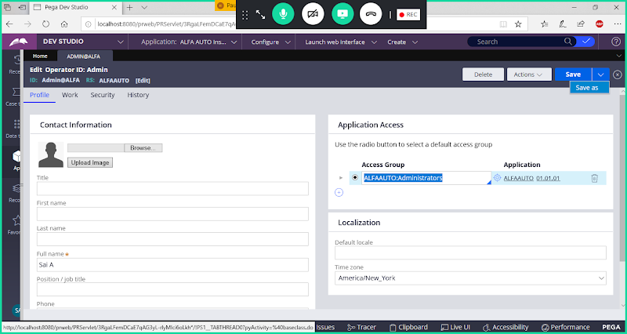

**Open & Update Label/UserID**

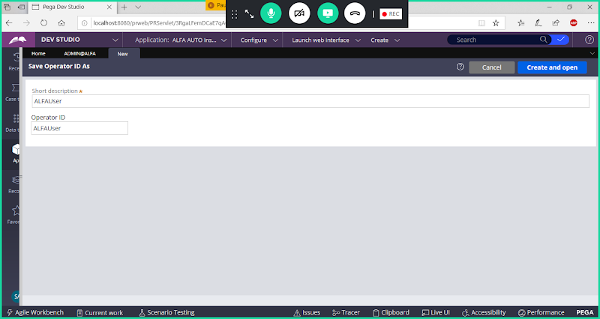

**Open**

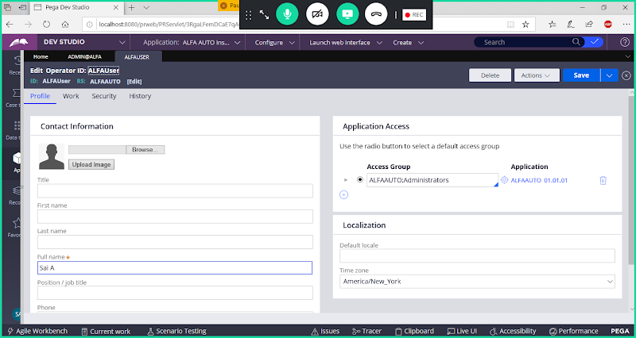

**Change Name & Access Group:**

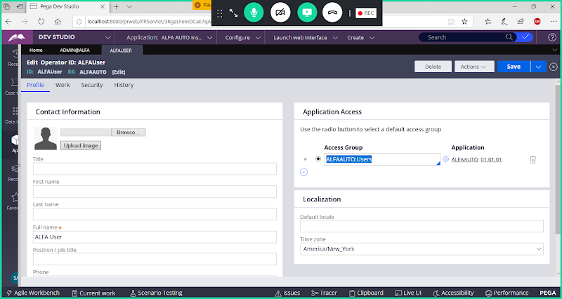

**Save User ID**

**Create SLA:**

**( Process-> Service Level Agreement)**

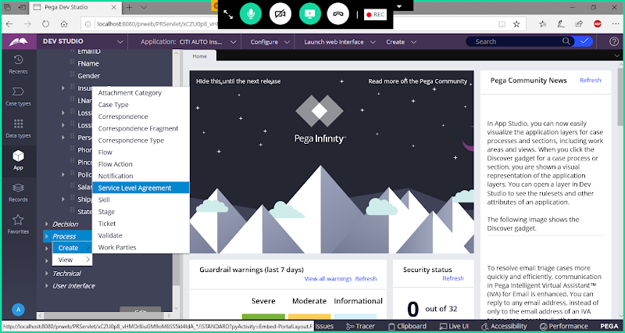

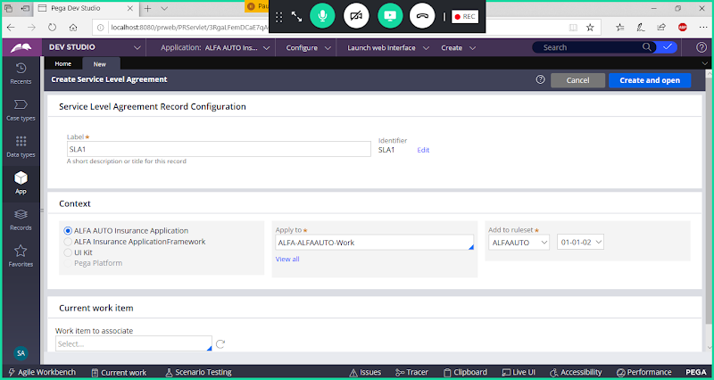

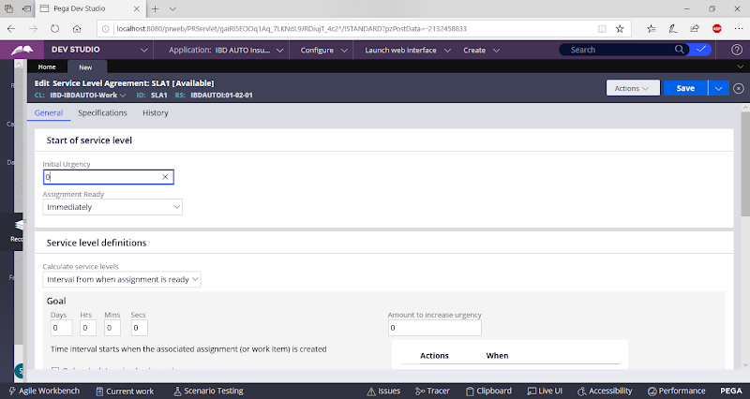

**Add Initial Urgency:**

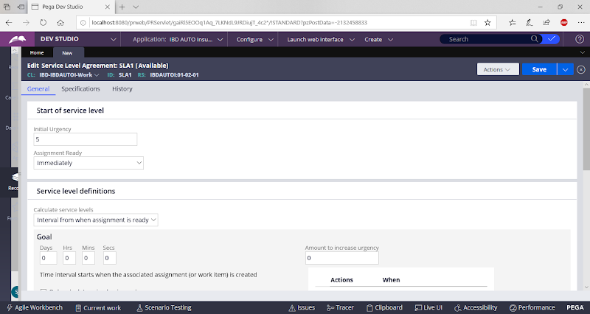

**Add Goal Time & Urgency:**

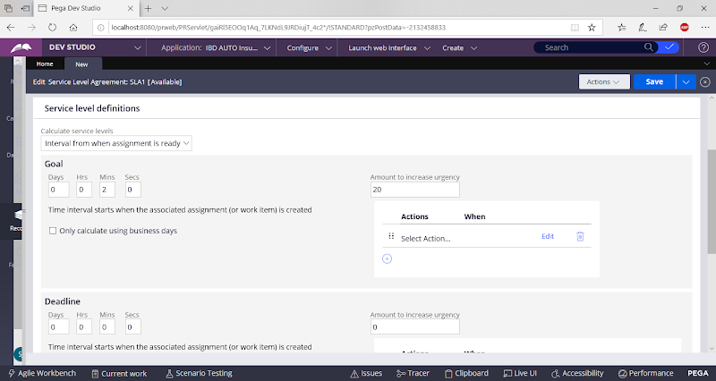

**Add DLT & PDLT:**

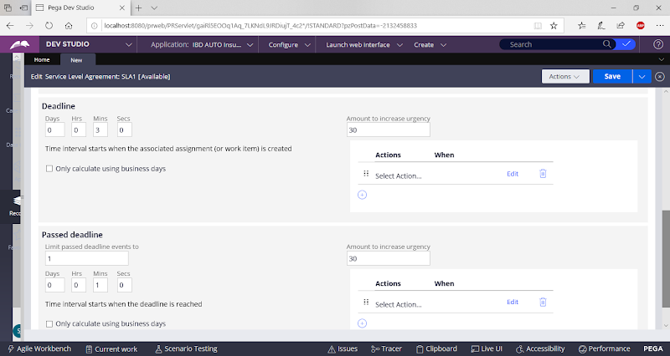

**Under GOAL Time Add Escalation Parameters using Action Transfer:**

**Double Click on Select Action:**

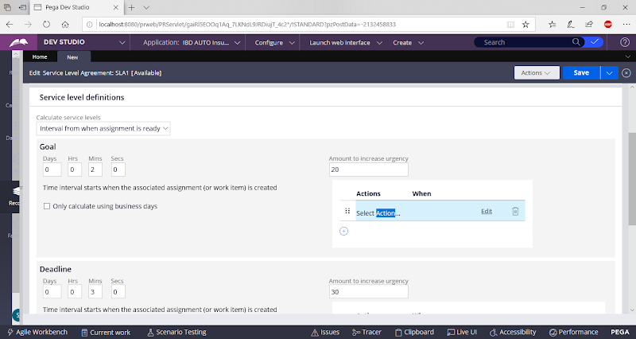

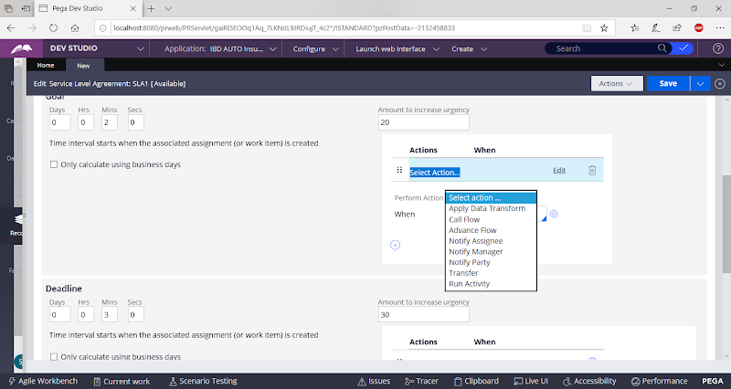

**Select Transfer:**

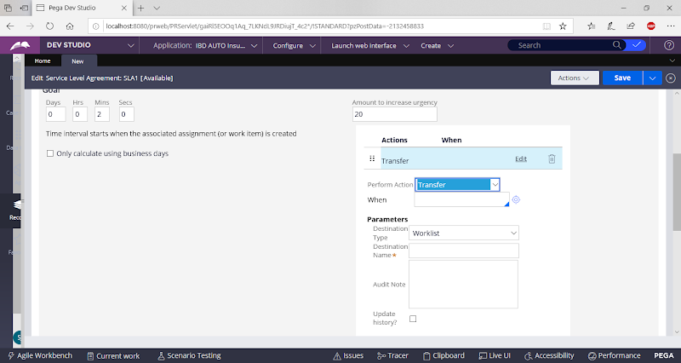

**Add User ID**

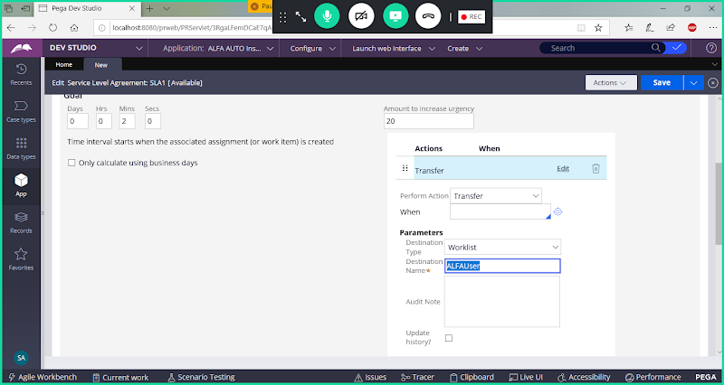

**Save SLA**

**Open Insurance Flow & Call SLA under Approval Assignment:**

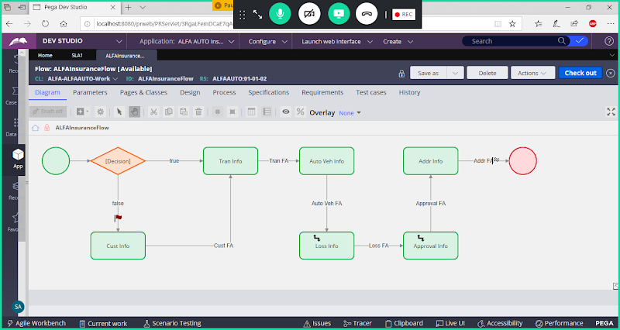

**Double Click on Approval Assignment & Add SLA:**

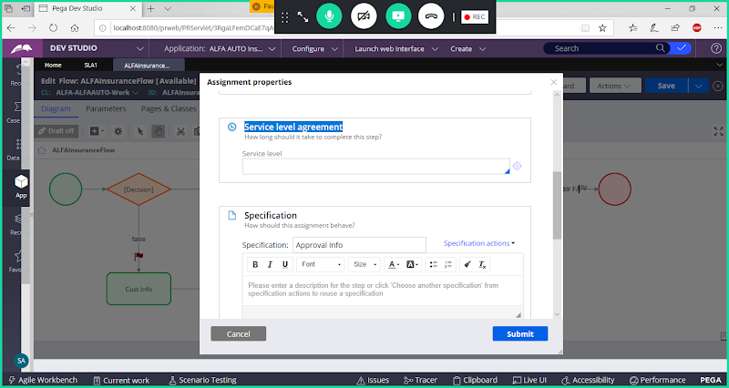

**Call SLA**

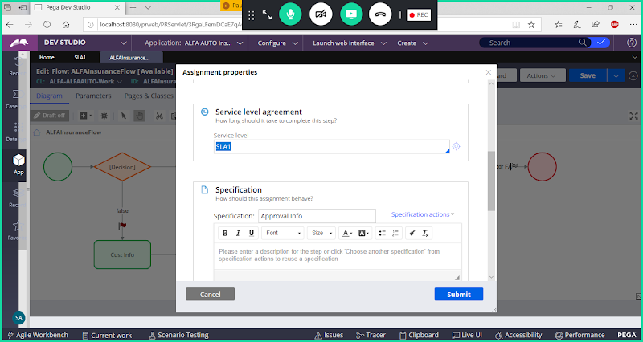

**Submit**

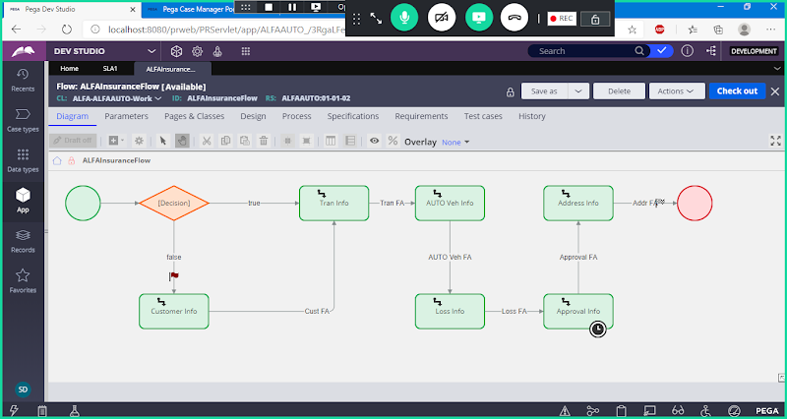

**Run the flow & Submit Till Vehicle Form:**

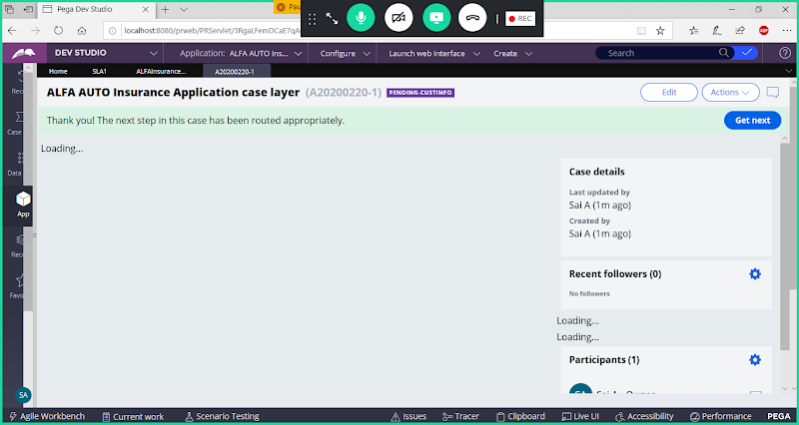

**Complete LOSS Form**

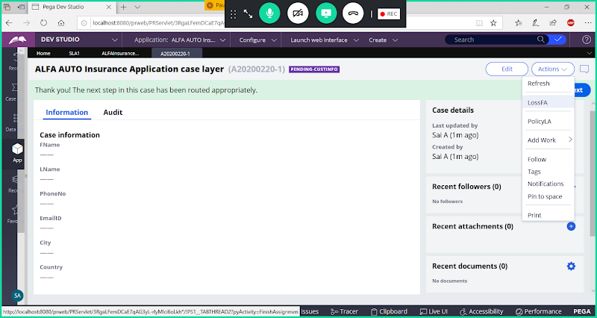

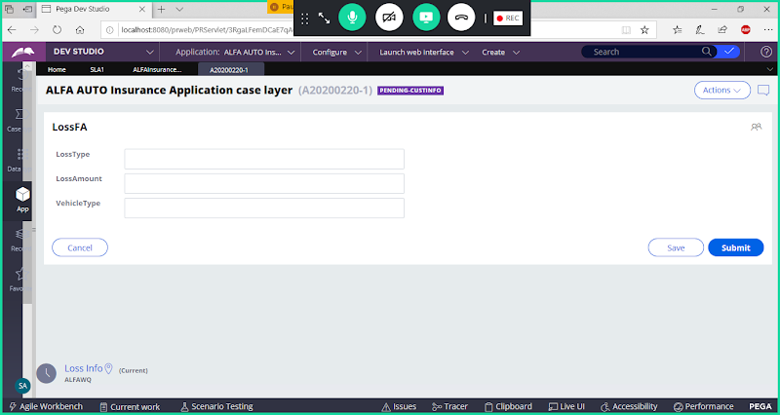

**Submit**

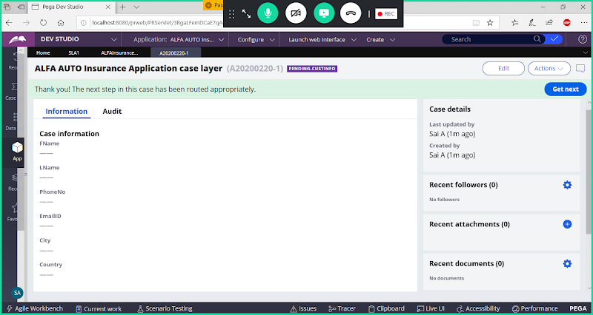

**In Manager Portal after Work Item is Routed, after goal time(2min) is breached, task will be routed to User Portal**

**Login to Manager Portal: ALFAManager1**

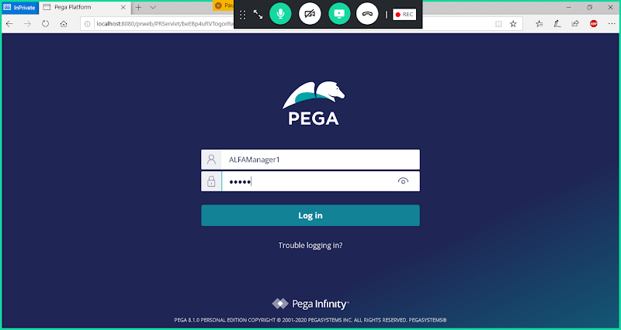

**After 2 min Work Item is routed to User Portal.**

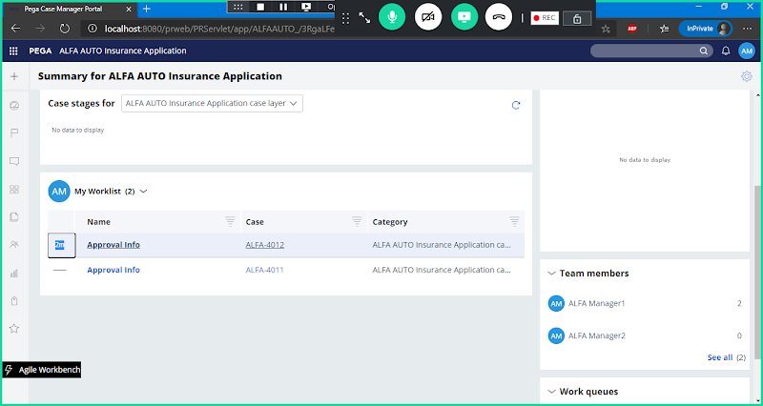

**After 2min Work Item will be Routed to User ID**

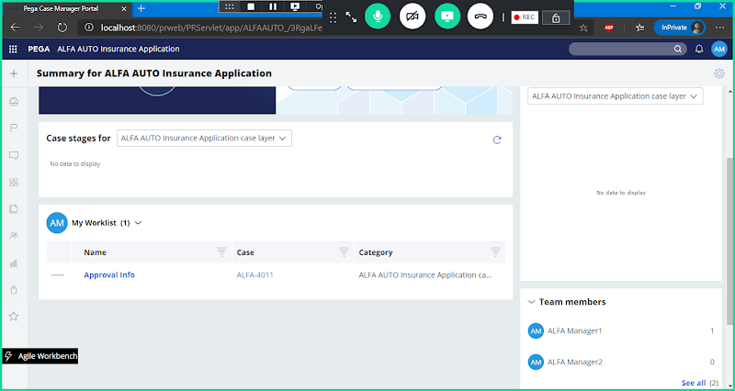

**Now login with User Poratl ID:**

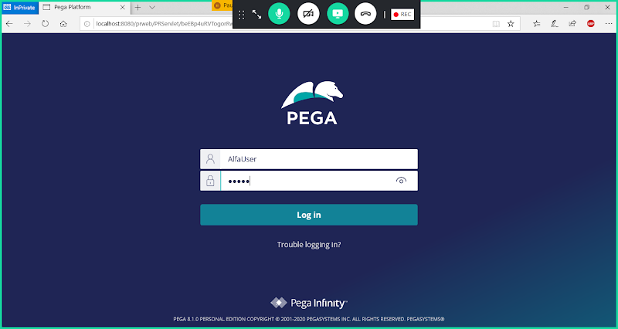

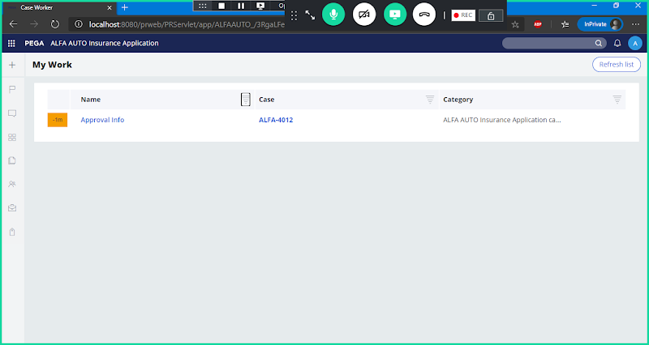

**Complete the WO from User Portal**